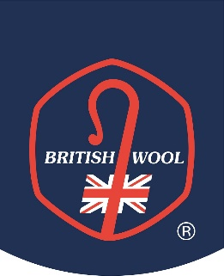
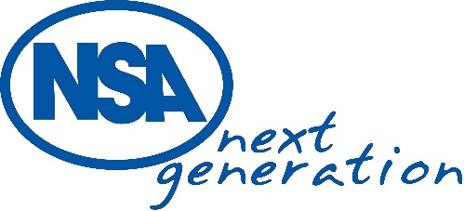

NSA Next Generation visit British Wool and Haworth Scouring plant – ‘The Next Generation Wool Symposium’ – Monday 14 – Tuesday 15 October 2024
Terms and Conditions
- NSA and British Wool will accept up to 12 interested sheep farmers aged 18 to 35 to join them for this opportunity to visit British Wool and Haworth Scouring and share views on the future of the UK wool industry.
- The visit includes an overnight stay in Bradford.
- Applications open for interested individuals to attend the NSA Wool Symposium on Wednesday 28 August and close on Monday 30 September.
- Successful applicants will be notified on Wednesday 2 October. Unsuccessful applicants will be notified by Friday 4 October.
- Accommodation, food and visits for successful applicants attending the symposium will be funded by NSA and British Wool. Travel to and from and during the symposium, and all beverages at the hotel, are at the applicants own cost.
- Accommodation is for shared occupancy (same sex) of a twin room unless otherwise stated. Exceptions may be made for those requiring single occupancy for a genuine reason.
- The visit is open to NSA members and non-members however those not currently a member are encouraged to sign up before attendance at the visit.
- All attending NSA Next Generation events must behave in such a way that they do not cause a nuisance or make reasonable disturbance to those also staying at the accommodation provided, on transport provided, on visits or at other locations visited such as restaurants.
- NSA is GDPR compliant and will store any personal information you provide to NSA securely, as outlined in the NSA Privacy Policy. By applying to join the visit, applicants consent to NSA sharing their data with British Wool.
- Successful applicants agree to press and publicity as part of NSA and British Wool promotional work this will include photography. Successful applicants agree that views expressed by individuals during the symposium may be shared as part of the publicised headline messages from the event.

