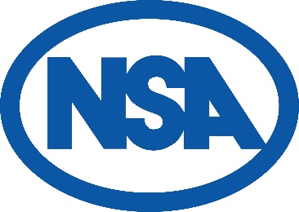
NSA South East Region
Opportunity for NSA Regional Manager

The nine regions of the National Sheep Association (NSA) play a vital role in the organisation’s success. They ensure that the views and needs of grassroots farmers are represented across all areas of NSA’s work, while also providing opportunities for members to exchange experiences, voice opinions, and access valuable information through regional events and activities.

NSA South East Region is seeking a new Regional Manager to oversee and coordinate its activities across Berkshire, Buckinghamshire, Hampshire, Kent, Oxfordshire, Surrey, Sussex, Wilshire and the Isle of Wight. This is a paid flexible administrative role.

This position is ideal for someone organised and enthusiastic, who enjoys working with people and has an interest in the sheep sector. You’ll be supported by a friendly and experienced regional committee, with plenty of scope to shape the role around your strengths.

The role offers an annual honorarium of £2,250 plus expenses, with responsibilities designed to fit around other commitments.

The regional manager role includes:-
- Organise and minute at four committee meetings annually, three online and one in person, including the Annual Regional Members’ Meeting. Work with the regional chairman to set agenda items and implement agreed actions.
- Coordinate a small number of regional activities approved by the regional committee, such as farm walks, meetings, Field days, and support the annual NSA South East Region Ram Sale.
- Assist with the organisation of two larger events held biennially, the NSA South East Region online SHWAP conference, and the NSA Next Generation Shepherd Competition (regional qualifier for the national final).
- Work with NSA Head Office to communicate relevant information to regional members through NSA channels and ensure the region operates efficiently.
- Join occasional online catch-ups with other Regional Managers and NSA staff members to meet with and share ideas.

An induction will be provided by NSA Head Office, with ongoing support available. To apply for the NSA South East Region role, please send you CV and covering letter to Fiona Parker, NSA Activities and Support Officer, by Friday 5 June 2026.
- To apply or for general questions, contact Fiona on fiona@nationalsheep.org.uk or 01684 892 661.

