17-12-2024 BTV Survey Final Report
Responses: 244
Locations:
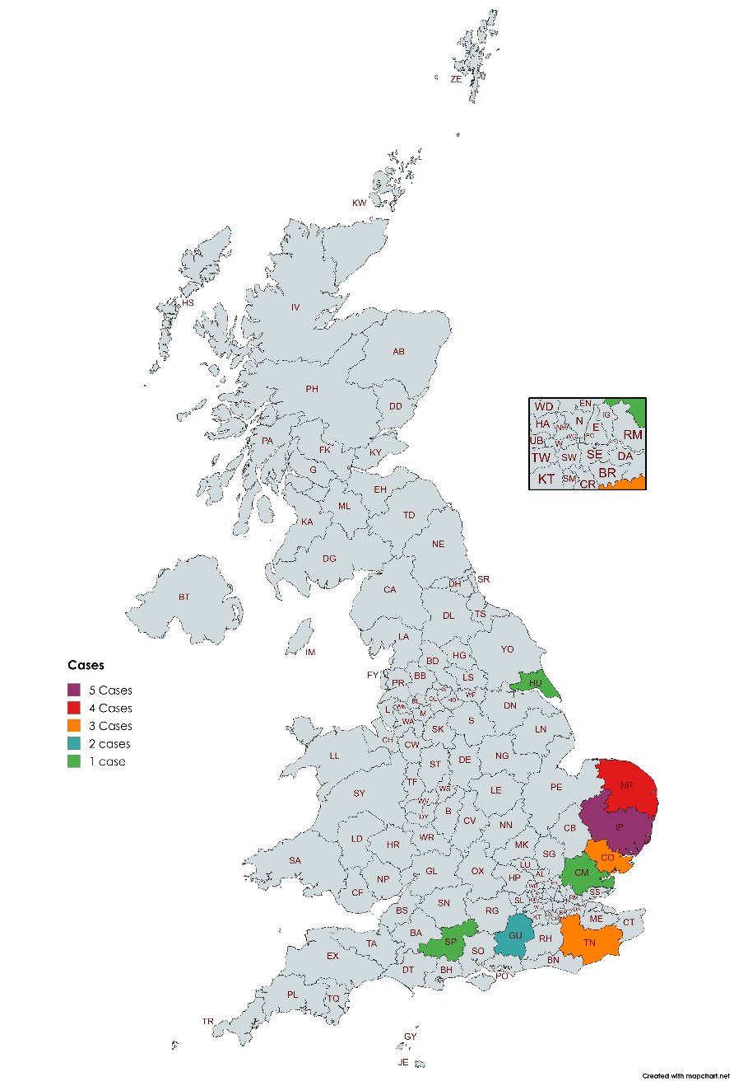
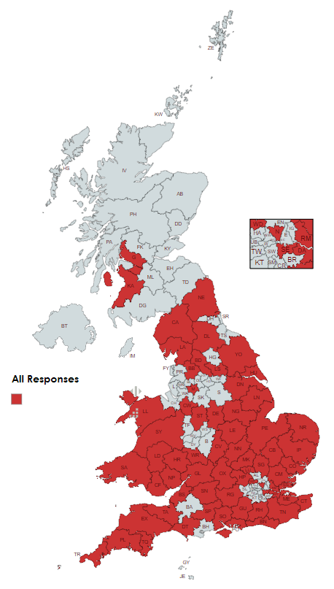

Cases:
20 case farms (18 confirmed and 2 pending confirmation). Dates range from 28th July – 3rd October 2024.

Definitions:
Herd Morbidity – Number of clinically ill/total number animals
Herd Mortality – Number of dead animals/total number of animals
Case Fatality – Number of dead animals/number of clinically ill animals
Beef Cattle:
Highlights - Low morbidity and mortality in beef cattle (no dairy cases reported yet, note that in the Netherlands milk drop was a major clinical sign in dairy cattle)
Farm | Number Adults | Number Followers/  Youngstock | Number Diagnosed | Number Ill | Number Died/ Euthanised | Herd Morbidity  (%) | Herd Mortality  (%) | Case Fatality Rate  (%)
9 | 50 | 50 | 3 | 0 | 0 | 0 | 0 | 0
19 | 440 | 1300 | 1 | 75 | 0 | 4.3 | 0 | 0
34 | 34 | 42 | 6 | 0 | 0 | 0 | 0 | 0
57 | 26 | 44 | 23 | 0 | 0 | 0 | 0 | 0
65 | 10 | 10 | ** | - | - | - | - | -
91 | 5 | 16 | 1 | 0 | 0 | 0 | 0 | 0
99 | 10 | 17 | 0 | 1 | 0 | 3.7 | 0 | 0
100 | 7 | 8 | 10 | 5 | 0 | 33.3 | 0 | 0
106 | 70 | 82 | 3 | 0 | 3 | 0 | 2.0 | *
168 | 100 | 200 | 1 | 6 | 0 | 2 | 0 | 0
176 | 60 | 250 | ** | - | - | - | - | -
195 | 14 | 31 | 3 | 10 | None | 22.2 | 0 | 0
* Animals culled for control purposes (not ill)
** No beef cattle cases (farm has sheep which were diagnosed)
Symptoms:
None (7), Nasal Discharge (3), Lameness (3), Sore Teats (2), Tender Feet (1), Eye Discharge (1), Abortion (1), Drooling (1)
Treatment:
None (6), Insecticide (2), Homeopathic Remedy (1), Culled for Control Purposes (1)

Sheep:
Highlights – Low numbers of animals affected but a large number of those diagnosed or ill go on to die.
Farm | Number Adults | Number Followers/  Youngstock | Number Diagnosed | Number Ill | Number Died/ Euthanised | Herd Morbidity  (%) | Herd Mortality  (%) | Case Fatality Rate  (%)
9 | 35 | 25 | * | - | - | - | - | -
22 | 0 | 12 | 5 | 6 | 2 | 50 | 16.7 | 33.3
34 | 30 | 45 | * | - | - | - | - | -
38 | 175 | 50 | 1 | 5 | 4 | 2.2 | 1.8 | 80
53 | 550 | 450 | 1 | 1 | 1 | 0.1 | 0.1 | 100
65 | 30 | 30 | 1 | 1 | 1 | 1.7 | 1.7 | 100
100 | 33 | 69 | 3 | 3 | 3 | 2.9 | 2.9 | 100
106 | 8 | 51 | * | - | - | - | - | -
132 | 27 | 43 | 3 | 6 | 0 | 8.6 | 0 | 0
133 | 100 | 180 | 0 | 4 | 0 | 1.4 | 0 | 0
168 | 250 | 250 | 2 | >30 | 15 | >6 | 3 | 50
176 | 4500 | 3000 | 0 | >100 | 1 | >1.3 | <0.1 | <1
179 | 22 | 36 | 1 | 1 | 0 | 1.7 | 0 | 0
180 | 8 | 3 | 1 | 1 | 0 | 9.1 | 0 | 0
234 | 30 | 80 | 1 | 2 | 0 | 1.8 | 0 | 0
* No sheep cases (farm has beef cattle that were diagnosed)
Symptoms:
Lameness (6), Mouth Ulcers/Sores/Scabs (5), Swollen Head/Face/Jaw/Eye (5), Nasal Discharge (4), High Temperature (3), Drooling/Hypersalivation (3), Reluctant to Stand (3), Swollen Coronary Band (2), Inappetence (2), Mastitis (1), Depression (1), Separate from Flock (1), Smell from Mouth (1), None (1)
Treatment:
None (5), Antibiotics (4), Metacam (4), No Success (2), Insecticide (1), Ivy (1), Honey (1), Nettle Tea (1)
Other Ruminants:
Three case farms had other ruminant species: Goats (2) and Llamas (1). No animals were ill or diagnosed from these species.

Vaccination Intentions:
Intend to Vaccinate? | Number | Percentage
Yes – ASAP | 25 | 10.2%
Yes – Before Summer | 34 | 13.9%
Maybe | 90 | 36.9%
No | 93 | 38.1%
No Response | 2 | .8%
Grand Total | 244 | 100%

Vaccination Plans:
Species | Number
Sheep | 83**
Cattle | 45
Camelids (e.g. Alpaca) | 9
Goat | 2
Other Ruminants* | 2
Species Unknown | 17
Undetermined | 7
No Response | 98
* Deer and Reindeer
** One flock already vaccinated
Recommendation Vaccination for Other Farmers:
Species | Number
Sheep | 84
Cattle | 57
Other Ruminants | 31
No | 110
No Response | 16

Questions About Vaccines?
Questions from recent responses ask about timing of vaccination, costs/availability and further disease information.

Other Comments:
Recent comments have a focus on the monetary impacts of the restrictions and difficulties experienced as a result with related financial losses.
“Loss of c£95k in sales of pedigree breeding stock”
“Unable to sell stores at our usual market. Nearest Market is 2 hours away so holding on to them for the time being”
“Cancellation of events e.g. shows and sales”
“The restrictions are causing more damage to me than the disease itself due to less competition in the market and extra costs incurred by processors due to nonsensical regulations. These restrictions should be withdrawn as a matter of urgency”

