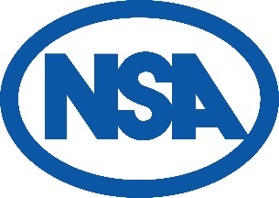
Notice is hereby given that the
131st Annual General Meeting of the National Sheep Association
will be held on Tuesday 13th August, 2pm at
31 Ballygowan Road, Kells, Ballymena, BT42 3PD
(by kind permission of Roger and Hilary Bell) by order of the Trustees

Agenda

The meeting will receive apologies for absence

- To approve the minutes of the 130th Annual General Meeting
- To receive
  - The Trustees Report to year ended 31st December 2023
  - The Statement of Accounts to year ended 31st December 2023
- To adopt the Trustees Report and Statement of Accounts to year ended 31st December 2023
- To elect officers for the ensuing year
  - The Rt. Hon. Lord Inglewood DL as NSA President
  - Dave Gregory as NSA Treasurer
- To elect NSA Vice Presidents

- Peter Baber
- Jonathan Barber
- John Brigg
- John Cameron
- Margaret Dalton
- Andrew Foulds
- John Geldard
- Bryan Griffiths
- His Grace the Duke of Montrose
- Dan Phipps
- David Raine

- To appoint Bishop Fleming as NSA auditors
- Any other business

Items to be considered under agenda item 8 should be notified to NSA Head Office via the same route and by the same deadline as proxy voting forms. Visit www.nationalsheep.org.uk/events for details.

